**Unit 2: Triangle Congruence** Name: __________________________________

Math 2 Test Review

Triangle Congruence

1. List the five ways to prove that triangles are congruent.

_______________ _________________ __________________ _________________ ____________________

1. For each pair of triangles, tell which of the above postulates will make the triangles congruent.
   1. 

* 1. 
  2. 
  3. 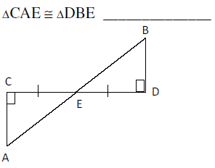

1. For each pair of triangles, tell (a) Are they congruent? (b) Write a triangle congruency statement. (c) Give the postulate that makes them congruent.

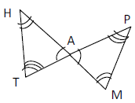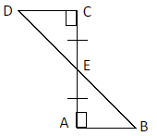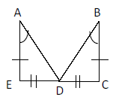

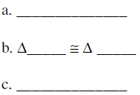

1. 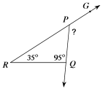Find the indicated angle measure.
   1. 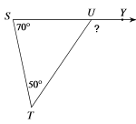
2. 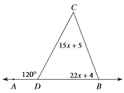Solve for x.
   1. 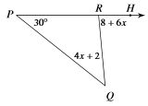
3. 